**ABSTRACT**

Smartphones have become a necessity for people that they have trouble imagining a day without them. Smartphones makes a person's life easier and more convenient. Through the installation of apps, the list of possible uses of smartphones grows every day. The fast processing of information is a must when competing in the business world. Being able to process the information in a short period of time results in more productivity.

In this study, the team proposed to develop a Student Records Management System for Bangkal Elementary School - Main. It will be a mobile application and the system will be cloud-based using Firebase. The system will cover the assignment of teachers for each section, the registration of students, the submission of subject grades the computation of final subject grades and evaluation of learner observed values and attendance for the report card, and the submission of Transcript of Record. The system's purpose is to create a consolidated record of student information. With the system being mobile-based, viewing and recording of grades will be faster, handy, just a click away.

**INTRODUCTION**

**Project Context**

DepEd has started to address the technology gaps among teachers and students. The public school in the Philippines is coping in what they call the Information Age. With DepEd providing technology support, public schools have begun integrating technology both in teaching and learning. In her speech during the Education Summit, DepEd's Bureau of Curriculum Development Director Jocelyn DR said that filling the gap in technology is the first step to further enhance the quality of education in the Philippines. She also called the students as digital natives, fluent in terms of digital technology, while teachers are called digital immigrants, not born into the digital era but have adopted. School heads all over the country have raised their concerns in technology integration regarding the improvement of the schools, emphasizing the importance of external partnerships with private sectors.

The team has proposed a project about implementing a Student Records Management System for Bangkal Elementary School - Main. The team aims to provide a centralized record management system for the records of the students in Bangkal Elementary School - Main, which can only be accessed through mobile devices. This will allow teachers of the school to be able to access and grade their students anywhere. All the information will be stored in the Firebase Storage that is backed by Google Cloud Storage.

**Statement of the Problem**

**General Problem**

* How to develop a Student Records Management System for Bangkal Elementary School – Main to easily consolidate student’s records?

**Specific Problem**

* How can the system register new students and update the status of old students?
* How can the system facilitate the submission of grades efficiently?
* How can the system mitigate the excessive use of paper?
* How can the system consolidate the grade records of the students?

**Purpose and Description**

The purpose of the project is to develop a Students Record Management System to centralize all the student information in Bangkal Elementary School - Main. The system will be a mobile application which allows registered faculties to access and grade students efficiently. The data is on the cloud which enables the teacher to take their work anywhere as long as they are connected to the internet allowing them to grade their student with no delay.

**Objectives**

**General Objectives**

* To develop a Student Record Management Mobile Application for Bangkal Elementary School - Main

**Specific Objectives**

* To develop a Teacher Module
* To develop a Class Adviser Module
* To develop a Principal Module
* To develop a Registrar Module
* To develop a Parent Module
* To lessen the process time of grade recording
* To mitigate the excessive usage of papers

**Scope and Limitations**

* The researchers focused on the processes of recording and storing of grades on Bangkal Elementary school - Main
* The researchers will use the processes gathered from Bangkal Elementary School - Main as a basis in developing the Student Records Management System.
* The system is only accessible through mobile devices.
* The team will use Firebase Storage
* The application needs internet connection to be used.

**Related Literature**

**Backend as a Service(Baas)**

Sliim Plangi conducted a study entitled “Overview of Backend as a Service platforms”. Sliim Plangi states that developing a fully featured mobile application often depends on server side capabilities. To lessen the burden of developing server side code, a new platform as a service type has emerged: Backend as a Service or BaaS gives application the most common server side capabilities like create, read, update, and delete (CRUD) operations for data and authorization, in a cloud-hosted model. Sliim Plangi added that BaaS does not require any server side code writing and is fairly easy to setup thus reducing development time. Backend as a service providers differ slightly and offer their own advantages over others but most of them have these key features.

* CRUD operations – The ability to create, read, update and delete data.
* Authorization – integration with existing social Open Authorization providers.
* Native notifications for mobile applications – sending push notifications to engage or notify users
* Query functions over data – search and retrieve specific parts of data to reduce network latency and memory consumption
* Administration console – edit the configuration of the Baas. May include a visual data representation with data editing options.

http://ds.cs.ut.ee/courses/course-files/Siim%20Plangi%20final%20report%20May2016-2.pdf

**Firebase**

According to an article posted by CMARIX, Firebase was established by Andrew Lee and James Tamplin back in 2011 yet was launched formally in April 2012 and was taken over by Google two years after the release. The great thing about Firebase is how easy it is to deploy multiple services in an application, and how those services can work together. Easy configuration and implementation of building blocks like realtime storage, crash reporting, and authentication can take weeks off an app’s time to market. The article posted by CMARIX shows the benefits of using Firebase. Benefits of Firebase are:

* Real-Time Database – when one user updates a record in the database, that update would be conveyed to every single user, be those users on a website, iOS or Android device.
* Authentication – Firebase Authentications provides backend services, easy-to-use SDKs, and ready-made UI libraries to authenticate users to your app.
* Storage – It gives secure document transfers and downloads for Firebase applications, regardless of network quality. Firebase storage is upheld by Google Cloud Storage, a capable, basic, and cost-effective object storage service.
* Notifications – It is a free service of Firebase which empowers focused user notifications for mobile application developers.

https://www.cmarix.com/14-benefits-of-using-firebase/

**Implementation of Students Record Management System**

A case study conducted by Karisha D. Kavuta and Samwel Nyamanga states that the concept of Student Record Management System (SRMS) refers to the situation where all the students related information to learning institution (schools, colleges or universities) are entered and kept safely in the computerized system for easy organization, retrieval and control. By definition, Student Record Management System is a special management information system for education establishment to manage students’ data. It provides capabilities for students to register their courses, documenting grading, results and other assessment scores, transcripts, build student schedules, track students’ attendance, and manage many other student-related studies data.

<http://www.ijstr.org/final-print/feb2018/The-Factors-Affecting-The-Implementation-Of-Students-Records-Management-System-To-Higher-Learning-Institutions-In-Tanzania-A-Case-Of-The-Institute-Of-Accountancy-Arusha.pdf>

**Document Management System (DMS)**

In today's business environment, most businesses, from small businesses to large corporate entities, organize and maintain a tremendous amount of information, particularly information in the form of paper-based documents and electronic documents. The task of organizing and maintaining such a large number of documents, as well as document types is time consuming and costly matter.

Due to the pain of searching for documents for extensive span of time and manually handling documents, many firms started implementing DMS. A DMS refers to the repository that store documents and allows end-users to retrieve and track documents. A research conducted by Robert Kelemen and Renata Hudek shows the advantages of having a DMS. Specified advantages are:

* Faster document distribution and retrieval
* Centralization of archiving; accessibility, security and control
* It makes the decision making process easier
* Better electronic documents handling
* It has no time-consuming document handling, archiving and searching
* Less space for achiving
* It reduces labor and streamline processing through automated workflow features
* It provides more convenient and faster access to case files
* It eliminates lost and misplaced files

**Mobile Applications for Business**

In an article posted by Techaeris states that mobile applications are a necessity for any business. The article posted stated benefits on why mobile applications are a must have for any kind of business. The benefits are:

* Consider mobile app as a sales booster
* Your customers are on their smartphones all the time
* Personalization makes users feel special
* Turn it into your powerful marketing tool
* Improve the customer experience
* Build brand loyalty

<https://techaeris.com/2017/09/21/seven-benefits-mobile-apps-business/>

**Electronic Class Record (ECR)**

The Department of Education announced that all public school teachers should follow and use the official and standard Electronic Class Records for all the curriculums’ subjects. This is to ensure the accuracy of grading and ranking of students. The templates of Electronic Class Records were simplified by the Department of Education, this is to guarantee sustainability and to minimize technical difficulty for the teachers. The Electronic Class Record is very convenient for teachers to use. They can easily access it with mobile phones, tablets, and computers. They just need to enter the score or grade of their students.

**Cloud vs. Personal Data Centers**

Today, firms have tons of choices when it comes to data storage. One of these choices is to host your data into the cloud or operate on data centers. The main difference between a cloud and a data center is that a cloud is an off-premise form of computing that stores data on the Internet, whereas a data center refers to on-premise hardware that stores data within an organization's local network

There are huge benefits to cloud adoption. Not only is it cost effective, but it also offers flexibility and efficiency. Here's why the cloud is better than personal data centers based from an author named Lauren Lovett.



* The cloud as a cost saving tool - In an on-premise data center, you will need to buy a server hardware along with networking hardware. Inevitably, this equipment will age and need replacing. This equipment will also need configuring, maintaining and securing. On-premise servers, then, can quickly become expensive. While in the cloud, you are not paying any upfront costs, you are storing your data on someone else's hardware and infrastructure. Cloud providers performs all updates and ongoing maintenance. Cloud vendors also adopt a per-user subscription model. meaning you only pay for what you need.
* Flexibility and resourcefulness - Hiring talent and building an exceptional organization need no longer be confined to the geographical location of your office. The burden of paying out for commercial spaces, equipment and maintenance fees for hardware is a thing of the past. Instead, by deploying the cloud and the various online applications now readily available to businesses, you can set up your employees from remote locations and ensure they have everything they need to do an effective job. With the likes of Turbine, you can manage your business and employees efficiently and automate a lot of the tasks that drain your time.
* Remote working with the cloud - Data centers, are not well known for their ease of accessibility for remote and flexible workers. With cloud, employees can work anywhere, anytime and they can collaborate as if they were in a physical office.
* Adopting the cloud for better business practice - It will enable your business to grow faster and more efficiently.

**Technical Background**

**Java**

Java is the innovation of decision for building applications utilizing structured codes that can be executed on cell phones and this is what the team will mainly use for developing the mobile application that will serve as the interface between the user and the system.

**Android Studio**

Android Studio is the official integrated development environment (IDE) for Android Development. It will act as the central hub for development. This is where the programmer enters the Java code, run and debug apps, and manage all project files. This is the software that provides your interface for coding and testing.

**Firebase Realtime Database**

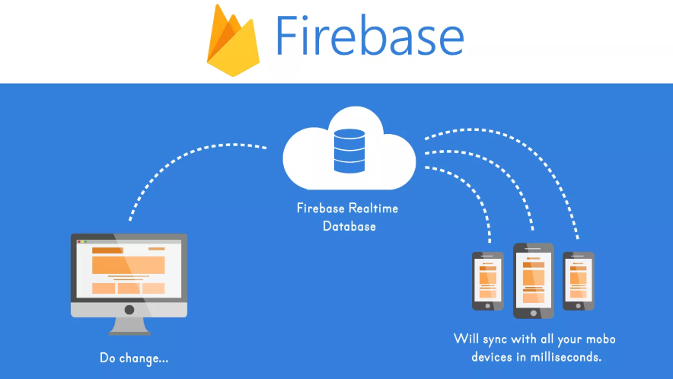

Firebase is a mobile and web application development platform. The Firebase Realtime Database is a cloud-hosted database. It helps your users to collaborate with one another. Data is stored in the cloud and synced across all clients in realtime and remains available when your app goes offline. It is linked as an assistant to android studio which is also a database

**Hypertext Preprocessor (Php)**

PHP code may be embedded into HTML code, or it can be used in combination with various web template systems, web content management systems, and web frameworks.

**MySQL**

Is the world's most popular open source database. With its proven performance, reliability and ease-of-use, MySQL has become the leading database choice for web-based applications, used by high profile web properties including Facebook, Twitter, YouTube, Yahoo! and many more. Oracle drives MySQL innovation, delivering new capabilities to power next generation web, cloud, mobile and embedded applications.

**XAMPP**

Stands for Cross-Platform (X), Apache (A), MariaDB (M), PHP (P) and Perl (P). It is a simple, lightweight Apache distribution that makes it extremely easy for developers to create a local web server for testing and deployment purposes.

**Mobile Application**

Mobile applications are a move away from the integrated software systems generally found on PCs. Instead, each app provides limited and isolated functionality such as a game, calculator or mobile web browsing. Although applications may have avoided multitasking because of the limited hardware resources of the early mobile devices, their specificity is now part of their desirability because they allow consumers to hand-pick what their devices are able to do.

The simplest mobile apps take PC-based applications and port them to a mobile device. As mobile apps become more robust, this technique is somewhat lacking. A more sophisticated approach involves developing specifically for the mobile environment, taking advantage of both its limitations and advantages. For example, apps that use location-based features are inherently built from the ground up with an eye to mobile given that the user does not have the same concept of location on a PC.